Workshop: DNA & RNA Structure

Introduction
In this workshop you will examine the structures of the two types of nucleic acids found in cells, DNA and RNA, from their nucleotide building blocks to their fully assembled, functional forms. You will also learn how specific structural features of DNA and RNA make them well suited to their particular roles in the Central Dogma of Biology (“DNA makes RNA makes protein”). Detailed knowledge of nucleic acid structure is critical for understanding the fundamental cellular processes of DNA replication, in which the genetic information is copied in preparation for cell division, and transcription, in which DNA is copied into RNA, the first step in gene expression.

Learning Objectives
At the end of this workshop, you should:
- Be able to identify the sugar, phosphate, and nitrogenous base portions of a nucleotide.
- Be able to identify a major structural feature that distinguishes a purine nucleotide from a pyrimidine and to justify the specific pairings of these types of nucleotides in the double-stranded structure of DNA.
- Be able to distinguish a ribonucleotide from a deoxyribonucleotide and to justify/hypothesize why the chemical structure of DNA is better suited to long-term information storage than that of RNA.
- Be able to identify the 5’ and 3’ ends of a nucleic acid strand and know how the two DNA strands are oriented in the double helix.
- Be able to explain why the base pairing of DNA makes it well suited for transmitting genetic information to successive generations and why A/T-rich DNA strands associate more weakly than G/C-rich DNA strands.
- Be able to give examples of data that contributed to Watson and Crick’s proposal of the double helical, base-paired structure of DNA.

Instructions
Forms groups of 3-4 as specified by your instructor. Appoint a group leader who will read the questions aloud to keep the group working together at the same pace. Be sure to allow and encourage all group members to participate. Putting into words what you don’t understand or explaining what you do understand to your teammates is part of this exercise. Your instructor will circulate through the room to answer questions if you get stuck and may stop you at several points to have everyone answer some polling questions to make sure you’re all on the right track. After this class, a key for the workshop questions will be posted. Be sure to check your answers against the key and clarify any discrepancies by reviewing the textbook reading or asking your instructor for further explanation.

Workshop Questions

A. Nucleotides
Recall that most macromolecules are polymers made from individual subunits (monomers) that are joined together by covalent bonds. The monomers that make up the nucleic acids, deoxyribonucleic acid (DNA) and ribonucleic acid (RNA) are called nucleotides. As illustrated in the generalized structure shown in Figure A.1 below, all nucleotides consist of three parts. What are these three parts? (Note: one of the parts is not labeled, but it is a functional group that you should recognize.)

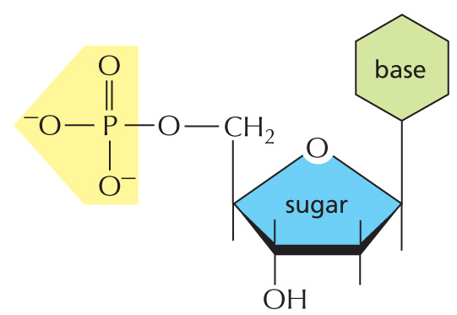
i. _________________________
ii. _________________________
iii. _________________________

Figure A.1. Generalized nucleotide structure consisting of three basic parts.
Copyright 2013 from Essential Cell Biology, 4th Edition by Alberts et al. Reproduced by permission of Garland Science/Taylor & Francis LLC. (Panel 2-6)

Sugars
The type of sugar that is present in the nucleotide is different for DNA and RNA nucleotides. DNA nucleotides contain deoxyribose, while RNA nucleotides contain ribose. The structures of these two sugars are show below.

- In Figure A.2 below, circle the parts of the two sugars that are different from one another.
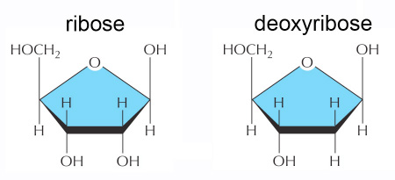
Figure A.2. Structures of ribose and deoxyribose, the sugars present in RNA and DNA nucleotides, respectively.
Copyright 2013 from Essential Cell Biology, 4th Edition by Alberts et al. Reproduced by permission of Garland Science/Taylor & Francis LLC. (Panel 2-6)

- Note that C-H bonds are generally less reactive than C-OH bonds. Given the difference you noticed in Figure A.2, provide a hypothesis for why DNA evolved as the macromolecule that stores hereditary information rather than RNA.

Bases
The five bases (also called nitrogenous bases) that are found in DNA and RNA nucleotides are shown in Figure A.3 below. Note that C, A, and G are present in both DNA and RNA, while U is specific for RNA and T is specific for DNA. As indicated in Figure A.3, the five bases fall into two structural categories, purines and pyrimidines.

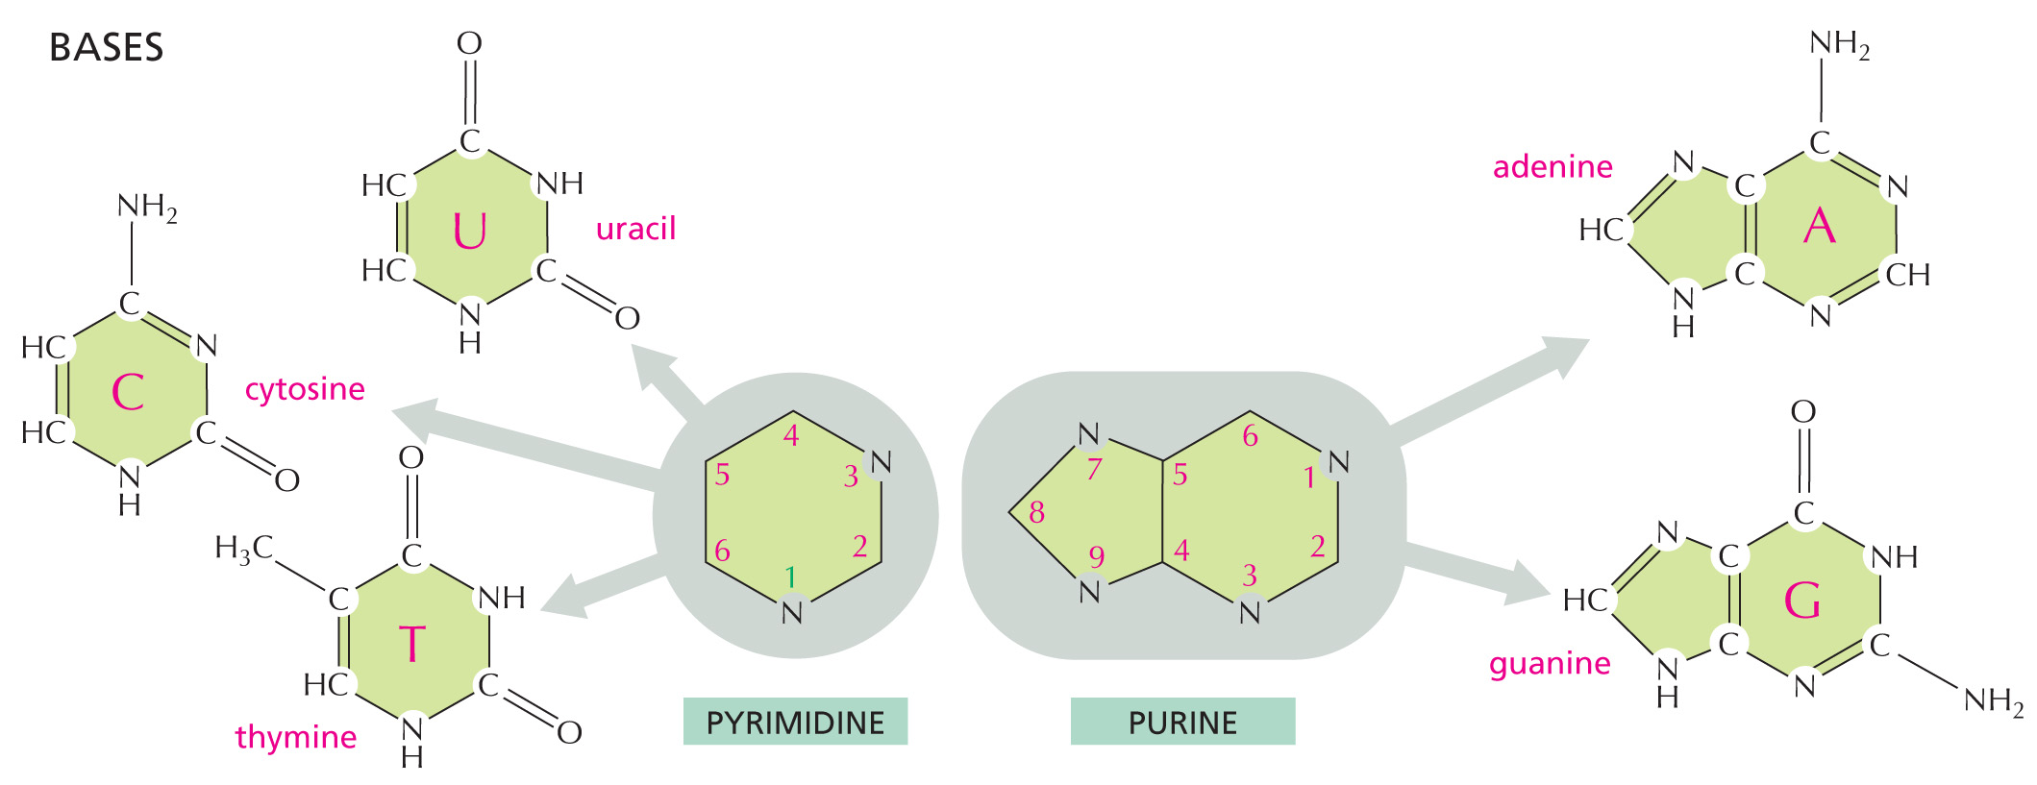
Figure A.3. Nitrogenous bases present in nucleic acids.
Copyright 2013 from Essential Cell Biology, 4th Edition by Alberts et al. Reproduced by permission of Garland Science/Taylor & Francis LLC. (Panel 2-6)

- Looking at Figure A.3, what is similar about all five bases? (Consider their overall structures and the fact that they are referred to as nitrogenous).

- How can you distinguish a purine from a pyrimidine? (I have a couple of mnemonic devices that I can share with you if you like!)

B. Formation of a nucleic acid strand (polymer)
Figure B.1. on the right below depicts the formation of a covalent bond between two nucleotides to form a di-nucleotide, the shortest nucleic acid polymer. Note that organic chemistry shorthand is used in this figure, wherein all corners represent carbon atoms and all lines without atoms notated represent bonds to hydrogens.
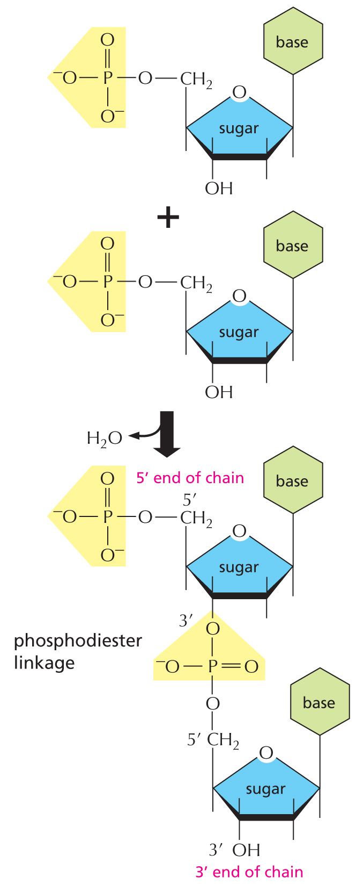
Figure B.1. Formation of a phosphodiester bond between two nucleotides to form a di-nucleotide. The bracket highlights the phosphodiester bond.
Copyright 2013 from Essential Cell Biology, 4th Edition by Alberts et al. Reproduced by permission of Garland Science/Taylor & Francis LLC. (Panel 2-6)

- Is the di-nucleotide shown in the figure DNA or RNA? How do you know?

- The linkage of two nucleotides occurs by what general type of reaction you have seen previously? (Note the by-product of the reaction.)

- Amino acids are linked by peptide bonds. What type of bonds link nucleotides in a nucleic acid? What two parts of a nucleotide become linked in this type of bond?

- Which functional group is free at the 5’ end of a nucleic acid chain? Which functional group is at the 3’ end of a chain? As a group, devise your own mnemonic device to remember this.
C. The DNA double helix
In cells, two linear strands of DNA associate and twist together to form a double helix. Figure C.1 below shows the interaction between the two strands (A) and the helical nature of the molecule (B). Your instructor will also show you an animated view of a larger portion of the double helix (https://commons.wikimedia.org/wiki/Category:DNA_helix-structures - /media/File:DNA_orbit_animated.gif).
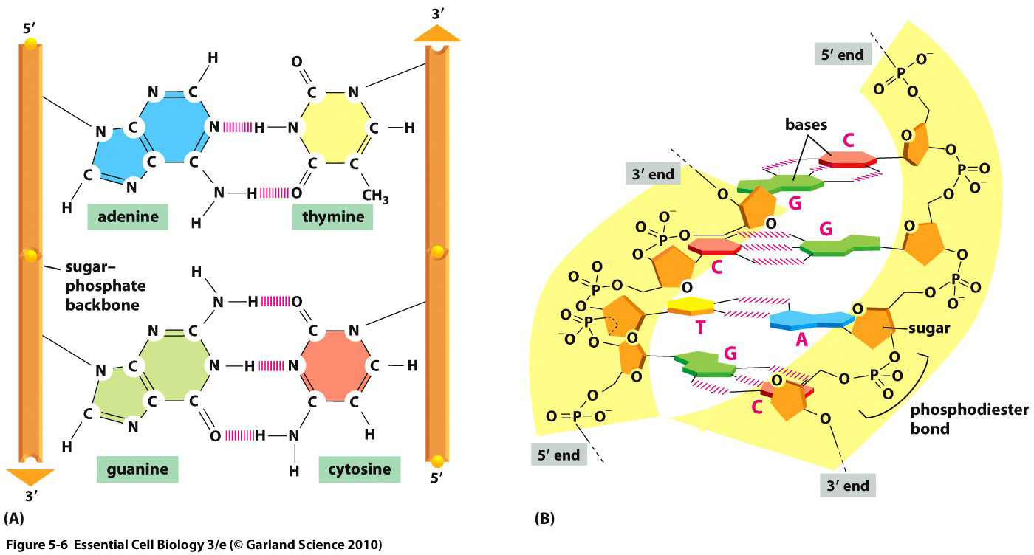
Figure C.1. The DNA double helix. A, arrangement of the two DNA strands, held together by complementary base-pairing interactions. B, one turn of the double helix, consisting of four nucleotide pairs.
Copyright 2013 from Essential Cell Biology, 4th Edition by Alberts et al. Reproduced by permission of Garland Science/Taylor & Francis LLC. (Figure 5-6)

- The two strands of DNA are arranged in what is referred to as an antiparallel orientation. From careful observation of Figure C.1, hypothesize what this means. (Hint: look at the ends of the sugar-phosphate backbone.)

- Based on your prior knowledge of how bonds are represented, what type of bonds hold together the two strands of DNA? What parts of the nucleotides are engaged in these interactions? (Refer back to the three parts of a nucleotide you identified at the beginning of this workshop.)

- Biochemist Erwin Chargaff discovered that, in DNA from all species, the number of adenine nucleotides matched that of thymines, and the number of cytosines matched that of guanines. Explain this observation based on the DNA structure shown in Figure C.1.

- The interactions you noted in #3 are referred to as complementary base-pairing. Do these interactions occur between nucleotides of the same category (purines and pyrimidines) or different categories?

- Watson and Crick arrived at the structure of DNA put forth in their 1953 Nature paper by building physical models that fit the existing data (see a photo of one of their models at: https://commons.wikimedia.org/wiki/Category:DNA_helix-structures - /media/File:DNA_Model_Crick-Watson.jpg)? From X-ray diffraction data acquired by Rosalind Franklin, they knew the spacing of the phosphate-sugar backbone did not vary along the length of the molecule. By experimenting with the cut-out purine and pyrimidine templates your instructor will give you, justify the nucleotide pairing you identified in #4. Why would another type of pairing not work, given the regular spacing of the two strands?

- Energy is required to separate the two strands of the DNA double helix. In vitro, this can be provided in the form of heat. An all G-C double helix would have a higher melting temperature than an all A-T double helix (i.e. would require a higher temperature to separate the two strands). Why? (Hint: look closely at the base pairing shown in Figure C.1.)

- Watson and Crick ended their 1953 paper with the following statement: “It has not escaped our notice that the specific pairing we have postulated immediately suggests a possible copying mechanism for the genetic material.” What did they mean by this? What would first have to happen to the two strands of a DNA molecule to allow such copying?

Watson J.D. & Crick F.H.C. Molecular structure of nucleic acids: a structure for deoxyribose nucleic acid. Nature 171, 737-738 (1953).
Ibid.

